#### What is Trello:

Trello is an open source, web-based platform that helps teams organize and manage any type of project, workflow, or task with boards, lists, and cards.

#### How to use Trello:

1. First, choose any available template that you are interested in using for your project.
2. Create a workspace to manage your project and team activities and tasks.
3. Create a board for your Project
4. Invite all the required teammates of your project at that project board and make your required listings and assign tasks.

#### 

#### My Work at Trello:

##### My trello dashboard:

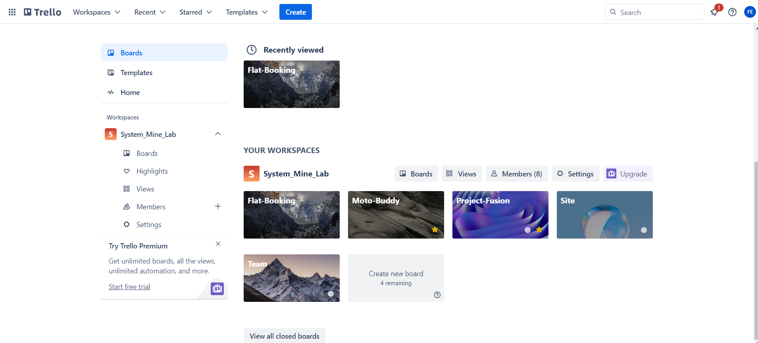

##### My Project board( Flat booking)

